**PRO192- Practice Exam – FALL 22 11/11/2022**

Duration : 85 minutes

Develop Staff management OOP application with following components and requirements

1. **Create MVC console application in NetBean:**
   1. Define class Staff with following attributes and methods: **(2 marks)**  
      + StaffID, Full name, Department, Password.   
      + Constructors, get/set(), toString()   
      + Method for change password that require old and new password. Staff are allowed to change new password if old password is correct   
      ***Note****: No IO console used in this model class*
   2. Define class StaffList with following attributes and methods: **(4 marks)**  
      + List of Staff  
      + Read text file to load data for StaffList – staff.txt is provided (1 mark)   
      + Method that can search staff by any criteria (1 mark)  
      + Method that offer staff login to the system (1 mark)  
      ***Note****: No IO console used in this model class*
   3. Develop StaffManagement class for application **(4 marks)**  
      + Main menu for application include: Display all staff, Search staff, Login, Change password (1 mark)   
      Hint: An abstract Menu class is provided for use in the application. Override method excecute()  
      + Method for staff login from console (1 mark)  
      + Method for a staff to change password from console (1 mark)   
      + Method for seaching staff with searching menu , [print out list of staff sorted by searching criteria] (1 marks)  
      + main() method to run the program   
      **Note**: This class allows interaction with user IO from console.
2. **Technical requirements**:  
   + Create package **model** for Staff and StaffList class.  
   + Create package **view_controller** for Menu and StaffManagement class.  
   + Checking error for input data.  
   + User interface as sample images below

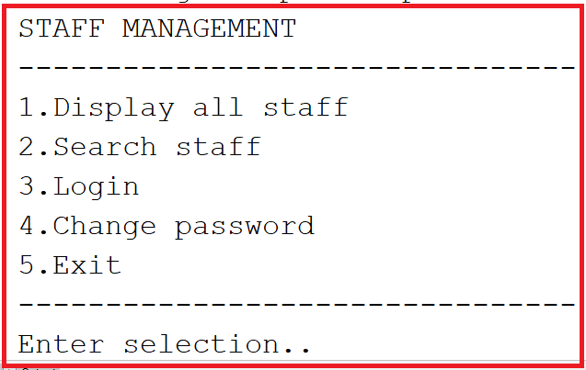

When choose search staff:

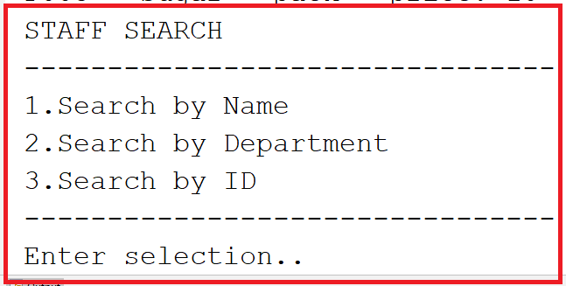

**Notice: Student must strictly follow all requirements as describe above for marking,   
Any modification the requirement detail is not allowed and will get no mark!**